|  |  |
| --- | --- |
|  | ELEKTRONICA-ICT  Project Embedded 2020-2021 |

**Autonomous Golfcart**

|  |  |
| --- | --- |
| Authors  Intern | Sam Knoors, Max Valkenburg, Berkan Ipek, Kazim Bozca, Metehan Altintas, Oguzhan Erdem  Frederik Vreys |

Abstract

The Autonomous golf cart is a project meant for the transportation from and to parking lots that are located far from office buildings, schools and city centres. This/It all needs to be comfortable, efficient and safe. The aim is to make this vehicle commute between two points without a human driver. Only in some circumstances will it occur that there is an unforeseen object in the path of the cart. When this happens, it is necessary that the cart moves around it with all the safety aspects in mind. This all happens with the use of cameras and radars combined with an artificial intelligence (AI). All the Physical actions are controlled by PLC. The PLC receives commands from the observation system and executes the necessary actions, for example increase or decrease the throttle or steer in a certain angle. To do this research there is a separate testbench to test some functions and measure all the movements and apply this to the AI. The advantage of this separate setup is that two teams can work on the same project and that tests can be executed without a driving golfcart.

This paper includes the part that is responsible for the PLC, user interface, and the communication between these and the artificial intelligence. The research question is “*What are the minimum requirements to design a system that is both safe and easy to use for an autonomous golf cart?*”

Content

1 Introduction 4

2 Material and methods 5

2.1 Flowchart 5

2.2 GPS-Module 5

2.3 4G-Module by mikroe and U-blox 5

2.4 Website 6

2.5 PLC 6

2.5.1 Inputs and outputs 6

2.5.2 Steering 6

2.5.3 Safety 7

2.6 Electronics layout 7

2.7 Relays PCB 8

2.8 Power 8

2.8.1 Power schematic 8

2.9 Testbench 9

2.10 RGB strip with HC-SR04 9

2.11 RFID Verification System 9

3 Results 10

3.1 Testbench 10

3.1.1 Steering wheel 11

3.1.2 Steering mechanism 12

3.1.3 Bottom plate 12

3.2 The program of the steering wheel. 12

3.3 Safety 12

3.3.1 Hardware 12

3.3.2 Software 12

3.4 Data 4G-module 13

3.5 Using the GPS-Module 13

3.6 Website 14

3.6.1 Registration and login form 15

3.6.2 OpenStreetMap API 15

3.7 Relays PCB 16

3.8 Power distribution board 17

3.9 Parking sensor with multiple HC-SR04 18

3.10 RGB strip with HC-SR04 18

3.11 RFID Verification System 19

4 Discussion 20

4.1 Test bench 20

4.2 Motion 20

4.3 Safety 20

4.4 Power 20

4.5 Website 21

4.6 Mikroe 4G module 21

4.7 Parking sensor 21

5 Conclusion 21

6 Reference list 21

# Introduction

The project started with the question “What are the minimum requirements to design a system that is both safe and user friendly for an autonomous cart”. In this application note a description is given of the materials and methods used, as well as the results.

The goal is to modify a regular golfcart so it can drive around the campus autonomously. The user should be able to switch between autonomous and manual mode with an onboard switch and see the current location via the website. Furthermore, admin personal can monitor the cart remotely via the 4G module. This makes troubleshooting and maintaining the cart easier. Moreover, passengers can monitor the status and actions the cart is taking by means of a tesla-like display and led strip.

The application note is structured as follows. Subsequent to this introduction, all the materials and methods that are used can be found/retrieved. This chapter also explains the purpose of each component individually. Next in chapter three, the results can be read of all the research that has been done. Followed by chapter four which is a discussion about the project and finally the answer to the research question.

# Material and methods

The cart is controlled using a PLC (Programmable logic controller) from Beckhoff in combination with a Jetson Nano and STM32. These devices are well known and as such have a good availability of examples and general information This makes programming, finding documentation and troubleshooting easier and more streamlined.

## Flowchart

At the heart of this project lies the Jetson Nano, it runs the AI and assigns the PLC how to control the cart. The PLC in turn controls the steering motor, the throttle, brakes, and various lights around the cart.

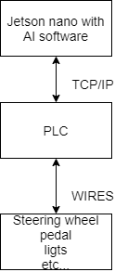The Jetson and PLC communicate with another through TCP/IP. This technology was chosen because safety is a top priority and this way, data integrity is ensured. As the arrow on figure 1 shows this communication flows both ways. If for example someone presses an emergency stop or turns the steering wheel while the cart is driving autonomously, the Jetson needs to know to stop the AI and return to manual operation.

Figure 1 overview flowchart.

## GPS-Module

Location services to this project are provided using the “Mikroe GNSS 7 click” module, which supports data exchange over several communication protocols.

Just like the 4G-module, this will also be linked by serial port onto the Jetson Nano.

Since “Mikroe” has already built a circuit board that supports serial over USB around the heart of this module, namely the “Neo M9N” GPS chip, it can be connected to the Jetson Nano or any other SBC without sacrificing an on-board serial port.

## 4G-Module by “mikroe” and U-blox

The 4G LTE click by mikroe is a module that supports cellular networking and communication using three LTE bands and GSM bands. It has also TCP/UDP and HTTP/HTTPS communication protocols. The chip used is a compact LARA-R2 series from u-blox. The specific model of the chip is the LARA-R211, that supports all this above. Mikroe created a click board that is used on the development board, through USB (UART) or using jumper wires. These pins are required: GND, 3V3, 5V, PWK, RX, TX. It supports any device that has Android/Linux. It is possible to run on windows, but a separate driver which available is on their [site](https://www.mikroe.com/) is needed.

## Website

The “Adminer” database was used to register customers (photo) and save the GPS coordinates that is send from the Jetson Nano, this system will offer a tidier user interface, better support for MySQL features, higher performance and more security. The application’s registration system and the login form communicate with the database by means of a PHP script.

The services of OpenStreetMap have also been used which offers various api keys for using different map applications. This API needs to be used in combination with a script to deploy it on your website. The last location of the cart appears in real time on the map, this is also realised by using a PHP script that always requests the last coordinates from the established database.

## PLC

The PLC used in this project is a CX9020 from “Beckhoff” and can be programmed with the “Twincat” IDE. To get things done with the PLC, there are some modular modules that can be clicked onto this. To control the lighting, switch between forward and reverse digital IO modules, to steer a Stepper in combination with a stepper drive module are used. Explained in detail below. In terms of safety, “Beckhoff” has some special safety modules that ensure that all running processes are safely terminated when the emergency button is pressed.

### Inputs and outputs

The PLC takes over all the peripherals of the existing controller in the cart. To do this there are some IO modules used. First, the drive direction which is manually controlled by a bistable three points switch that controls whenever the cart drives forward, backward or neither of these by putting the cart in neutral. Second the cart must be able to turn the lights on and control the turning sign. To do all this, the PLC needs a digital IO module in combination with a relay board to handle the current. The modules used in this project are the “EL1008” for all the inputs and the “EL2008” for all the outputs. The relay board is especially designed for the golfcart and contains eight relay terminals see 2.7 for more information.

When it comes to controlling the speed, reading the e-pedal signal is required. This pedal gives out a zero to five-volt signal using a potentiometer. To read this value the PLC needs an analog input module. In this project a “EL3062” module is used which turns the signal in a value between 0 and 65535. To pass this value to motor controller, an analog output module (EL8888) is used. This gives out a voltage between 0 and 10 volts using PWM.

### Steering

When it comes to steering, the AI and thus the PLC have full control of the golfcart. But in case of emergency, a human passenger can take over the steering wheel and the PLC will detect this and switches to emergency mode. A stepper and chain mechanism are used to take over the steering wheel. For now, this is assembled and placed onto the testbench to test and optimize the already written code. More about the testbench is described later in chapter 2.9 testbench.

### Safety

With safety being so important it cannot be trusted to the main PLC which is already busy controlling the cart itself. That is why a special “EL6900” safety PLC is used for this purpose. It is accompanied by its own safety input and output cards. The inputs are occupied by two emergency stops with one located on each end of the cart as well as a reset button, so the cart does not start immediately when the emergency switch is released. The main PLC and safety PLC communicate with each other through a special Beckhoff communication protocol named “Ethercat”.

Next the cart checks if the driver manually presses the brake or throttle or turns the wheel. This will turn off the autonomous mode and give the driver full manual control. If the cart deems a situation dangerous, like bad vision because of weather or a car on its side of the road, the cart will stop and tell the driver to take manual control.

## Electronics layout

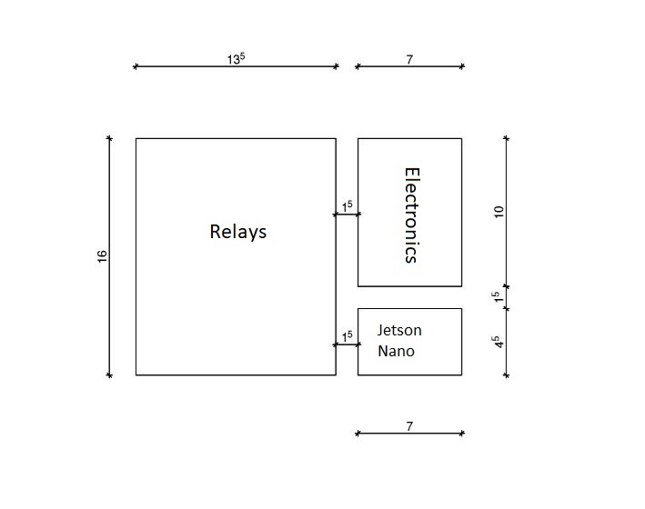

Figure 2 board layout

The relays PCB, the Jetson Nano and the electronics PCB will be installed as shown on Figure 2. The PLC and the power supplies will be installed underneath this configuration. The electronics PCB includes the following elements:

* 4G-module
* GPS-module
* micro controller

Every component on Figure 2 is oriented in a specific way which makes wiring easy and organised.

## Relays PCB

To control the main functions such as the electric throttle, low beam, high beam and the turn signals, an adequate number of relays are essential to the project. These relays will act like a switch to control the main functions of the vehicle. The PLC is the controlling unit for these relays that are installed on a printed circuit board by soldering them.

## Power

The following components need to be powered in this project:

* 4G-module
* GPS-module
* Jetson NANO
* micro controller
* zedboard FPGA
* PLC
* Stepper motor

Different power sources are essential to provide power to these components, because not all of them function on the same voltage. Dc-to-dc converters will be used to attain the needed power sources. These converters will be powered by a 48-volt Power supply, thus a 5-volts, a 12-volts and a 24-volts dc-to-dc converter will be installed.

### Power schematic

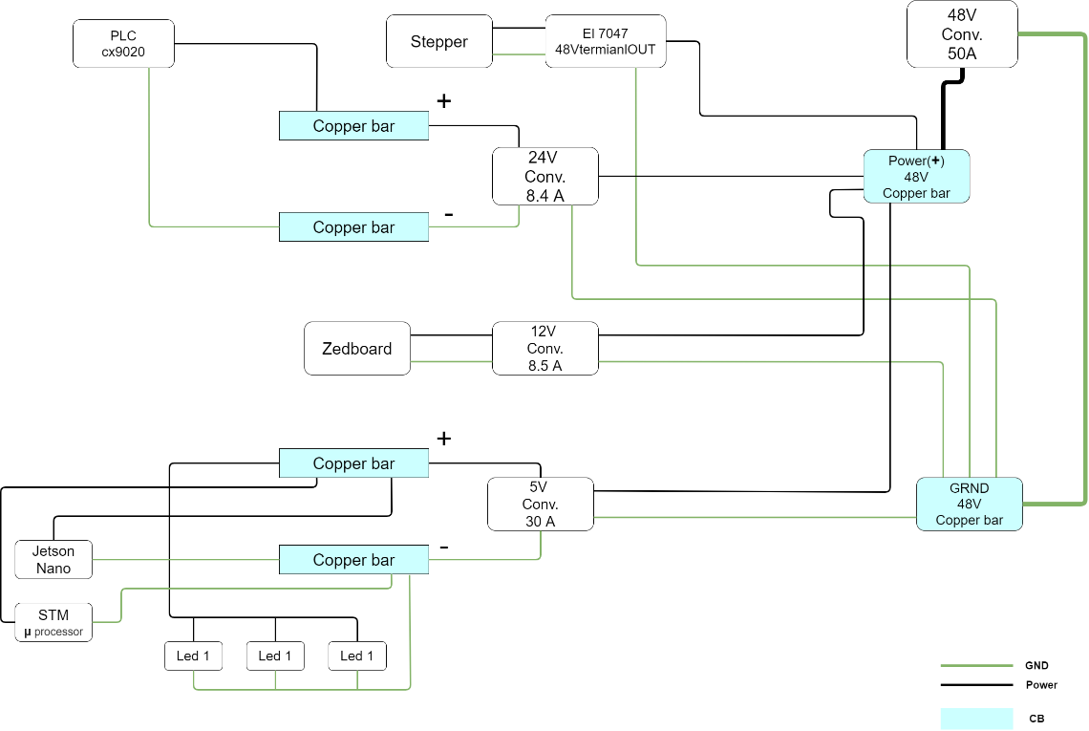

Figure 3 basic wiring diagram.

To power everything in the project, a good and organised power distribution is very important. The project mainly uses dc-to-dc converters with the exception of the main power supply. The main power supply is an ac-to-dc convertor which plugs in to the power outlet on the wall. In a later phase, the main battery of the golfcart will be used as the main power supply. Figure 3 shows the power schematic. As it can be observed the main power supply splits into three dc-to-dc converters. Respectively 24-volts, 12-volts and 5-volts. To eliminate the problem of not having enough electrical contact slots on the convertors, boost bars will be installed between each converter and its components. The boost bars are shown in blue on figure 3

## Testbench

The testbench of the golfcart is made of a basic race game /simulation setup and is modified with all the features that are required to test all the important functions of the autonomous golfcart. The setup consists of an e-throttle, steering mechanism including a stepper and the PLC and its accessories. The purpose of using a testbench is first, that it is safer than testing on the real cart and secondly, the bench can be used to test newly written code before putting it on to the golfcart. A third benefit of using this is that it can be used as an exercise setup for other future projects.

## RGB strip with HC-SR04

Many objects and obstacles will come in front of the golf cart. To inform the passenger of this, a piece of the LED strip is mounted on each side of the golf cart. when something comes closer to the golf cart, the LED strip displays this visually by turning on more leds and becoming brighter. The sensor that ensures that the distance to the object or obstacle can be detected is the ultrasonic sensor HC-SR04.

## RFID Verification System

The purpose of this system is to be able to start the car with a unique tag and without a physical key. The mechanical lock must be removed from the cart before it could be converted to an electronic verification system using RFID technology. The reason why RFID has been used and no other alternative like BLE Beacons is that RFID technology is a renowned verification protocol and is cheap. While being user-friendly.

# Results

## Testbench

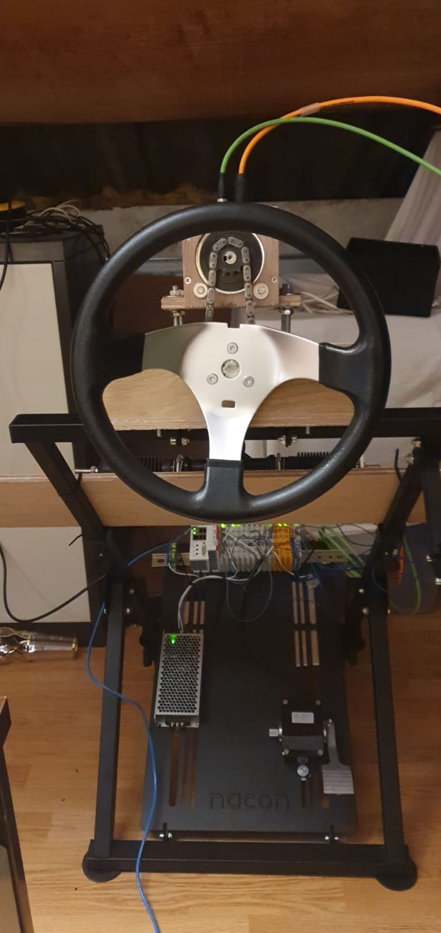The testbench is made up with separate modules, all these modules give it the functionality of simulating the real golfcart. Figure 3 shows a full setup version of the testbench. To make an almost identical mechanical copy of the cart, all the mechanical parts are original spare golfcart parts. This chapter discusses all the modules separately.

Figure 4 full assembled testbench.

### Steering wheel

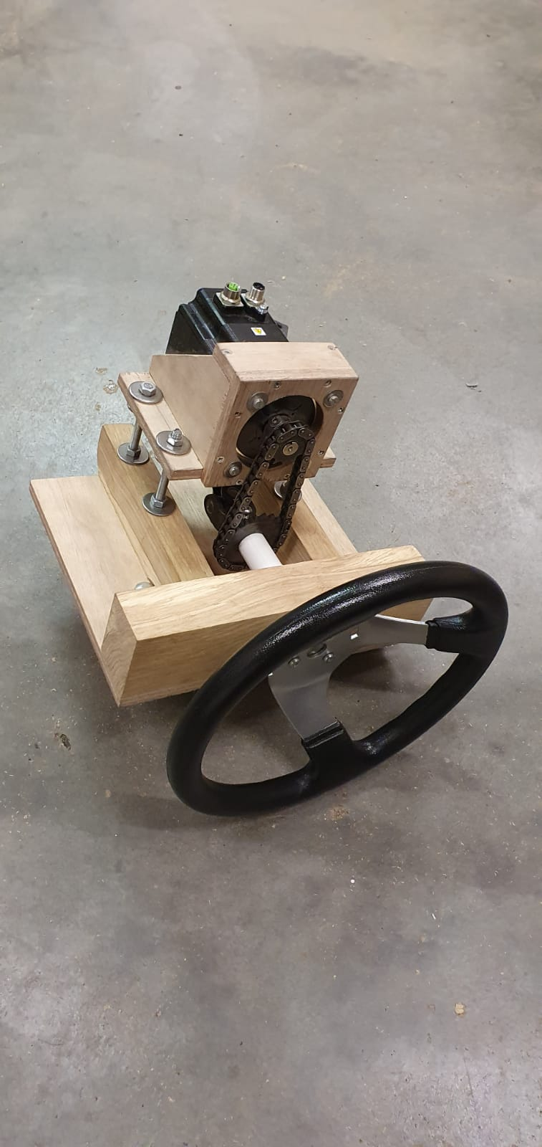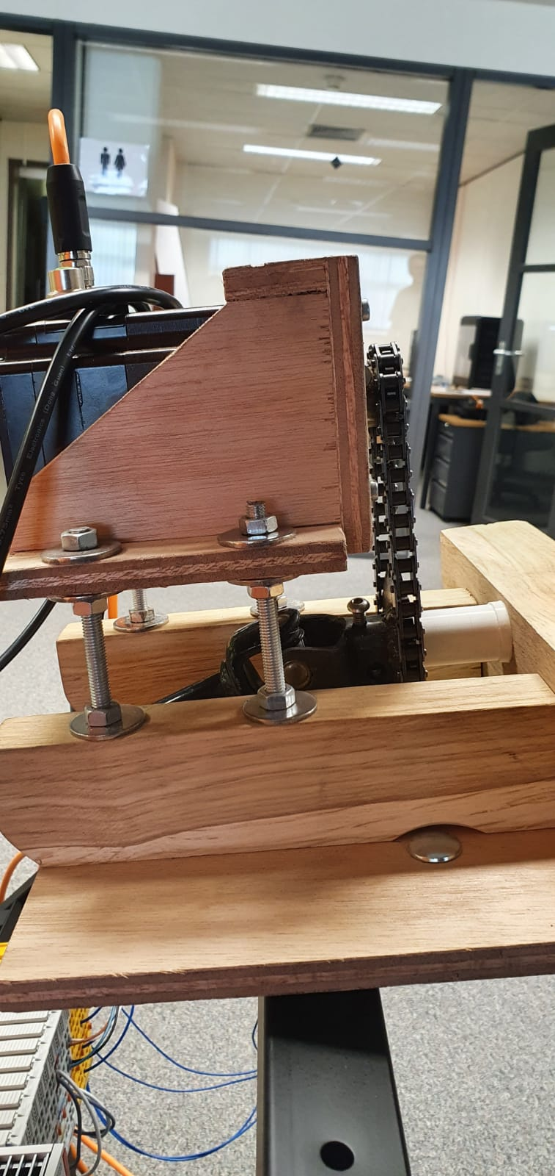The left side of Figure 5 displays the construction of the steering wheel. The construction is made from wood and steel threaded rods because these are easy materials to work with. The result of this construction is that it is compact, solid, and easy to adjust. On top of this module, the stepper can be viewed. Also, the green cable is a signal cable that sends pulses from the encoder to the PLC and the orange powers the two coils in the motor according to which step must be taken. By turning the highest two bolts of each threaded rod, illustrated on the right side of figure 4, is it possible to adjust the tension on the chain. The chain sprocket that is located at the shaft of the stepper showed in figure 5 can be adjust by loosening the bolt, but the sprocket located at steering shaft is fixed. This module is mounted on to the original building plate of the gaming frame.

Figure 5 Steering module and side view.

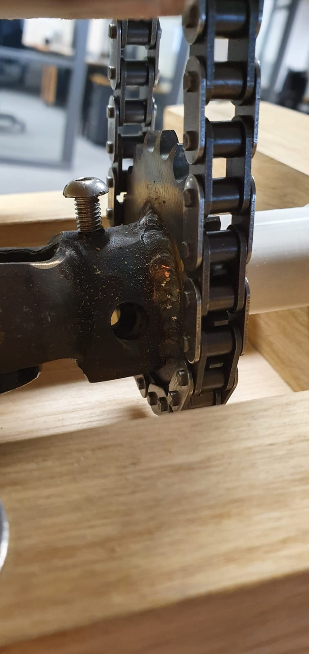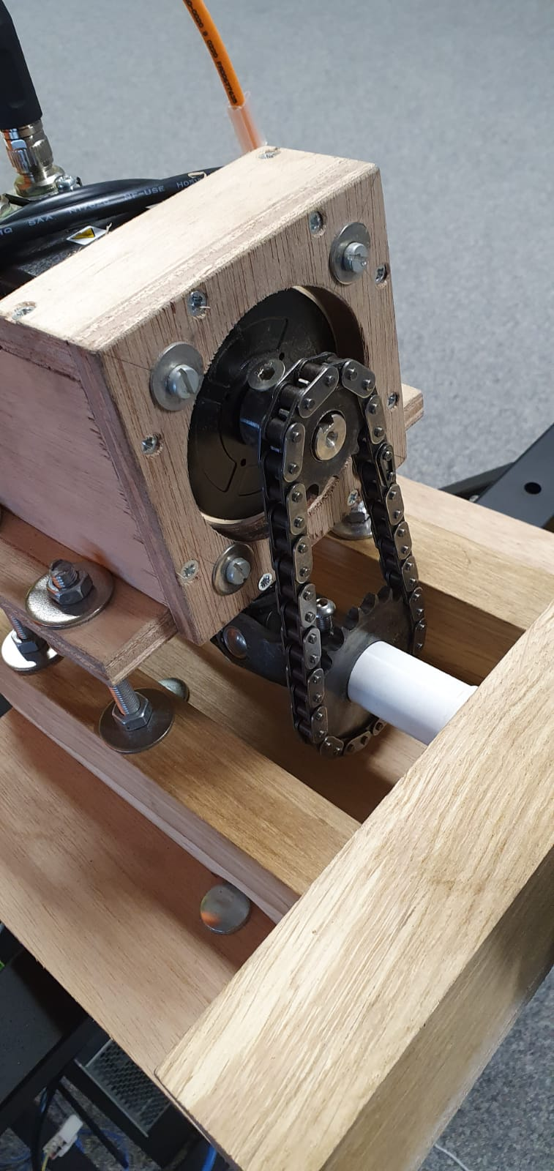

Figure 6 Close up view of the sprocket chain.

### Steering mechanism

Figure 7 close-up steering gears.

The steering gears are also mounted on to the setup (shown in Figure 7). This makes it possible to simulate the actual steering angle of the tires. Next to this module, an end-switch is mounted to give the PLC a signal when the maximal angle is reached. This part of the setup is connected to the steering wheel by a universal shaft.

### Bottom plate

All the hardware needed to make this setup such as the power supply, PLC, converters, and other electronic components are mounted on to the bottom plate. This is the easiest and most elegant place because it is possible to mount it in front and on the backside of the plate.

## The program of the steering wheel.

To let the Jetson Nano, take control of the golfcart, it needs to communicate with the PLC. By sending commands through TCP/IP, the PLC knows what to do with each command. So, for the steering the golfcart, it just sends the amount of steer movement in angles and on which speed it must turn. These parameters are calculated by the brains of the golfcart.

## Safety

### Hardware

The two emergency stops with two internal NC (normally closed) contacts are connected alongside the reset button. The NC contacts are connected in parallel so the safety PLC can see the if one or both loops are disconnected.

### Software

The two emergency stops are implemented with independent time checks. This means that each contact of each switch is individually monitored with a small test pulse every 50ms. If one loop suffers a broken cable the safety plc will still handle like a button is pressed but will tell the driver one loop is broken. The cart cannot be reset until the problem is resolved. Speaking of which the reset button is also implemented to reset the cart after an emergency.

There is also a flag that the normal PLC can use that is true when there is an emergency to enable or disable certain features in an emergency situation.

## Data 4G-module

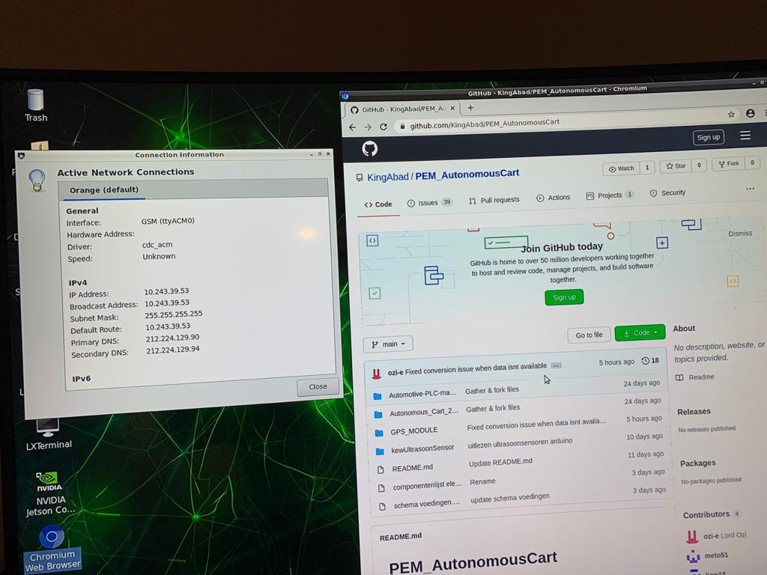The purpose of this 4G-module is supporting the Jetson Nano an internet connection. Through a mobile broadband connection, it was able to connect the module with the Jetson Nano. Because the Jetson Nano is a Linux based board, the module did not need any driver or installation to get it worked/functioning. The module connects with the Jetson using an USB cable. The cable supports UART obviously, so it sends data to the Jetson.

Figure 8 active network connections.

The window on the left side of figure 8 shows the “Active Network Connection”, this shows that the module is connected and running. The web browser on the right, shows a working internet connection through the 4G-module.

## Using the GPS-Module

This module uses standardized NMEA-sentences to send data to a receiver through its serial bus.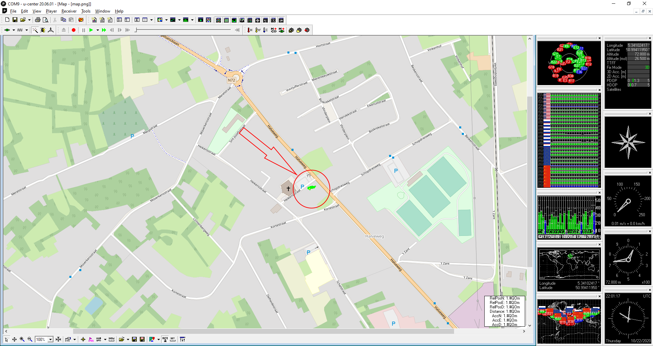 The bus is currently set to operate on 38400 bauds and will send out GPS data at a frequency of 10Hz. This is adjustable within the u-centre software that is compatible with and provides a clean GUI for this device.

Figure 9 current location.

The green set of lines inside the red circle as illustrated above in figure 9, represents where the device is currently located. The accuracy of the GPS-module is advertised as two meters; however, it seems to be lightly more in practice. Which means the AI-team will have to compensate using their own set of sensors.

From a cold start, this module will also take approximately 24 seconds to find and return GPS coordinates.

The program written in our project will read this NMEA data from the serial port, convert it into degrees and store it into a variable in python as requested from the product owner.

This is universal, meaning it works on any l-Linux operated SBC that supports python and USB.

## Website

An online platform is also created for people who want to use the autonomous cart. It works as follows: first, the customer needs to register on the online website so that the user has a personal account. If the registration is successful, the customer is directed to the login form where the client can log in with the account information.

Once the customer logged in, he gets to the main page where he can see general information about the project, the people who worked on it and the real time location of the cart.

The customer can now send requests to the cart to be picked up and make personal adjustments to the account that are beneficial to the client such as adding a route that is frequently used by the user in the category of favourite routes. A flowchart of this service is illustrated in figure 10.

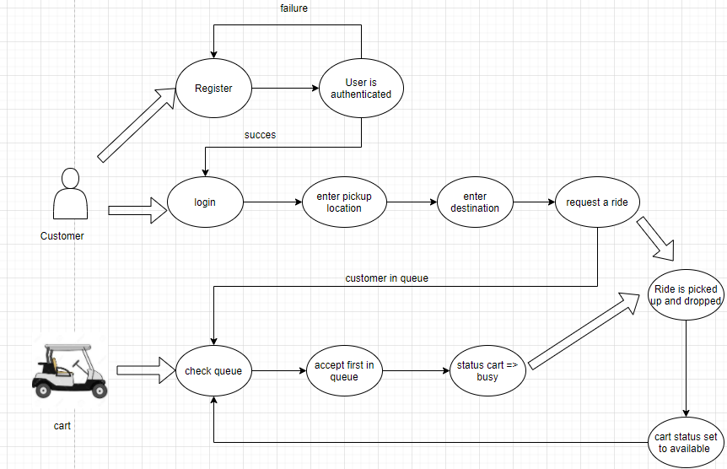

Figure 10 site flowchart.

### Registration and login form

A registration and login system has been set up as shown in Figure 11 below. There a number of JavaScript libraries like bootstrap used in conjunction with CSS templates to accomplish the design of the website. Also, a database has also been set up to store the customers like shown in figure 12. The database configured with a username password and email where the data of the customer is stored.

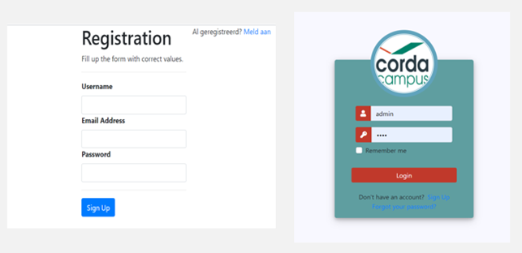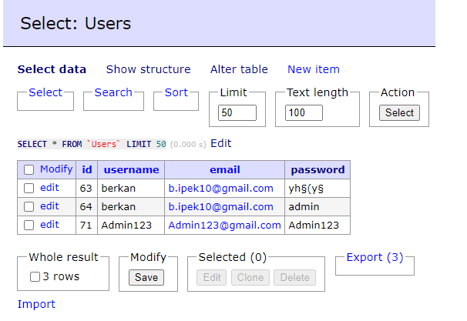

Figure 11 login screen.

Figure 12 database of users.

### OpenStreetMap API

To display a map on the website, an API had to be used. The Chosen API is the “OpenStreetMap”. This API is open source, so it is free to use. To make the API work, it needs to be used in combination with a script. The one that is used is the Leaflet JavaScript. Leaflet is the leading open-source JavaScript for interactive maps. It works efficiently across all major desktop and mobile platforms; it is easy to use and is well documented. It offers us several functionalities that can be used, but what has been used so far is showing the real time location of the car.

The location of the cart is displayed by requesting the coordinates from the GPS. It happens as follows, in the Jetson Nano insert a GPS module that requests the coordinates from the cart every millisecond. Then by means of a Python script the longitude and latitude are forwarded to the created database with a post request. On the website side there is a php script that always requests the last row of the database otherwise it would not be real time. Figure 13 shows the real time location in “OpenStreetMap”.

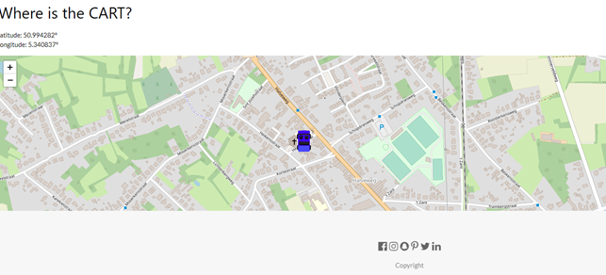

Figure 13 location in OpenStreetMap.

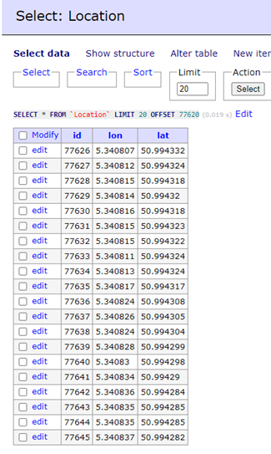

Figure 14 location database.

## Relays PCB

All the headers have been successfully soldered onto the PCB, however, a problem occurred while soldering the relays. The footprints of the relays were drawn upside down. This resulted in the whole PCB being upside down. The relays would only fit if they were soldered to the bottom of the PCB.

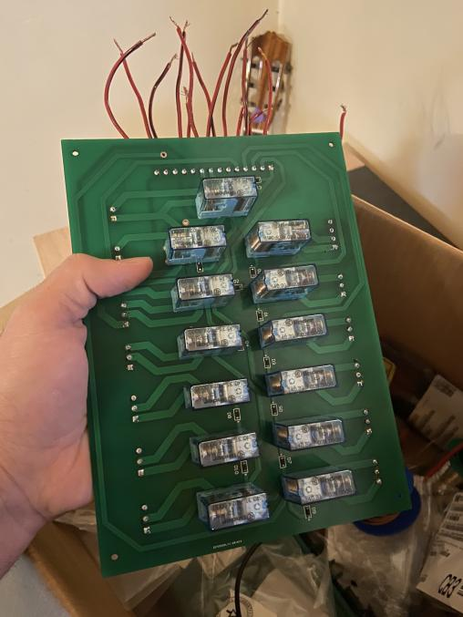

Figure 15 First soldered version of relay board.

Notice that the relays were soldered to the bottom of the PCB on figure 15. All the relays have been tested individually and they are working as intended.

## Power distribution board

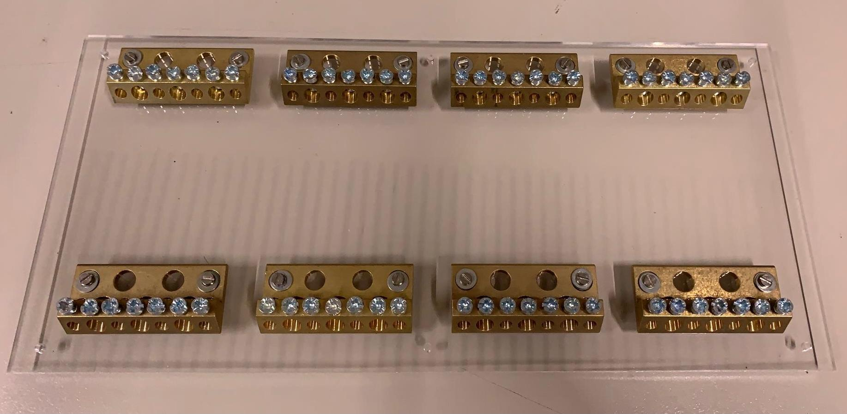

Figure 16 Power distribution panel.

The design of the power distribution board it is made of Plexiglas, this is the physical version of the schematic explained above. As shown in figure 16, screw terminals are mounted on a four-millimetre-thick acrylic plate, that means it is reliable and strong enough to hold the eight “boost bars” in place. For each voltage two terminals are necessary for example: 48V needs a – and +, same for 24, 12 and 5 volts.

## Parking sensor with multiple HC-SR04

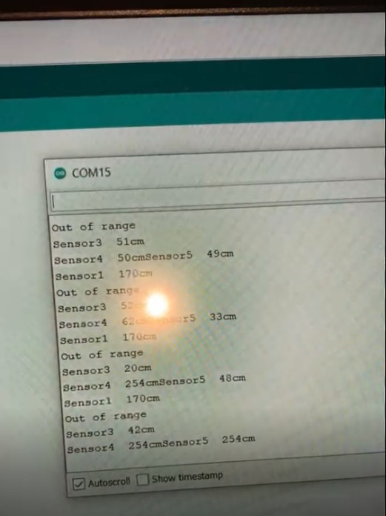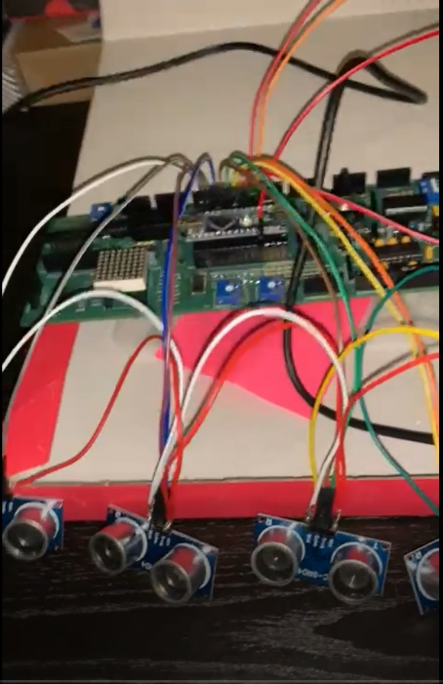By using an array of ultrasonic sensors, it was possible to create a parking sensor. These sensors were programmed with Arduino. The values from five sensors are useful for creating visual purposes. So, the values are only needed for the RGB strip that will be explained later. The left side of figure 17 shows the connection to the Arduino. On the right side the distance of each sensor is shown.

Figure 17 Multiple distance sensors.

## RGB strip with HC-SR04

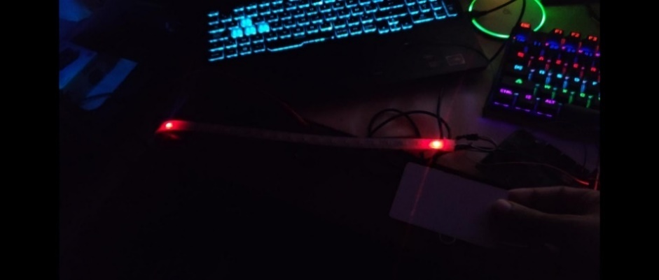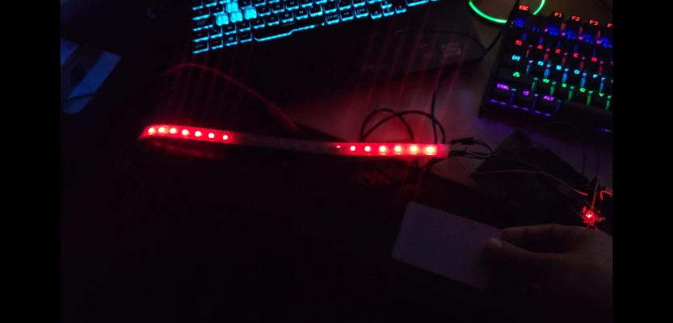Figure 18 shows that when the object is far away from the sensor, the LED strip does not turn on the LEDs. But as show in the right picture as the object gets closer and closer to the sensor, the algorithm causes more and more LEDs to turn on towards each other.

Figure 18 distance visualized by red led’s.

## RFID Verification System

As seen on the left side of figure 19, the system is connected with the laptop to see whether the tag data is being saved. This works perfectly and is currently implemented on the cart.

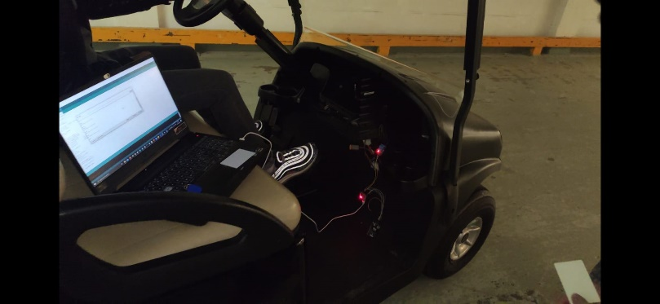

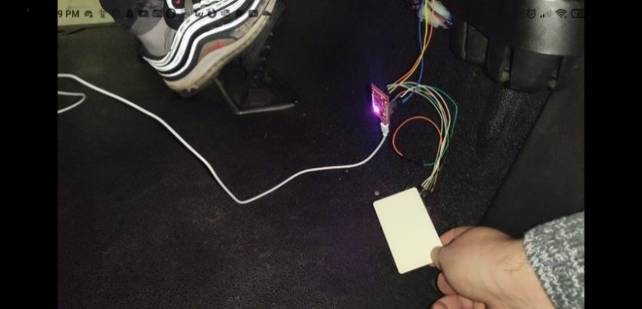

Figure 19 simulation of access control.

# Discussion

In this chapter, each part of this research is reflected by the team members themselves. What can be improved and what is future work.

## Test bench

The testbench is an ideal addition to the golfcart project because it is now possible to test and simulate all new features before it goes to the real golfcart. It also can be used for other micro mobility projects. In the future, the look of the testbench can be upgraded by using proper cable management and ridged mountings for all the components. Also, the functionalities can be expanded by adding more hardware and writing more software for it.

## Motion

For motion, the program is now verry limited in functions, so this is a point of improvement. For now, it is able to search for its end point and setting a movement range, map this range with an angle between -45 to +45 degrees. When it receives a command via the virtualization, it automatically moves to the desired position. The integration of the safety program and the TCP/IP program is future work.

## Safety

In its current state the safety aspect does not interact with the motion aspect. This means the cart keeps executing motion commands even if the emergency stops are pressed. Obviously, this isn’t the desired result but due to multiple setbacks it sadly wasn’t possible to implement. Taking this into account the safety part is in a good state now. The deactivation of the autonomous driving when user input is detected is finished and the emergency buttons are working as well.

## Power

Eventually, when everything is installed on the golfcart itself, there might be a problem with the battery. The battery might fail to supply the current needs of the project. The current draw of all the electronics might cause a decrease in power. This might affect the operating speed of the electric motors in the vehicle. In an extreme case, the electric motors might fail to move at all. Thus, in future work, it is important that the battery of the golfcart is examined thoroughly. The datasheet of the battery can be used to gather information about it. It is also a good practice to optimize every component in the project to consume as little power as possible.

## Website

For the website part several functionalities have been added such as the login and registration form and the real time location of the cart. In the future, a few features can be added such as creating favourite and most used routes, implementing payment and subscription options etc.

## “Mikroe” 4G module

The decisions were made and the 4G module from “Mikroe” was arrived, after a lot of testing and research it was able to get the Jetson Nano internet, so that they can process and request all data in real time. This mainly serves the backend of the project. This was the only purpose of the module and is considered done.

## Parking sensor

The purpose of the parking sensor was to create a visual output, to see how far obstacles are away from the cart. The sensor will only be implemented on the rear side of the cart. After experiments and coding it was a success, also the RGB output works and is ready to get installed on the cart. The RGB strip will tell how far away the object is because the algorithm causes more and more LEDs to turn on towards each other.

# Conclusion

The electronics needed to create the correct information means that it can read in various sensors in an efficient and fast way. Proper implementation of electronics ensures that every part is coherent. As far as this project is concerned, there is a need for a minimum requirement of an SBC (such as Jetson) offering Ethernet connectivity and connectivity to equipment such as the Ultra96 or STM32. Switching relays and the correct knowledge of software to allow external components such as the ultrasonic sensor or RFID scanner to communicate with the Jetson Nano via these microcontrollers is also required.

# Reference list

|  |  |
| --- | --- |
| [1] | K. Bozca, „Autonomous_Cart_2/PCB_RELAIS7-4/,” 11 April 2020. [Online]. Available: https://github.com/KingAbad/Autonomous_Cart_2/tree/Elektronica-bord/PCB_RELAIS7-4. |
| [2] | „Application Guide TwinSAFE,” Beckhoff, 13 August 2020. [Online]. Available: https://download.beckhoff.com/download/document/automation/twinsafe/applicationguidetwinsafeen.pdf. [Geopend 10 October 2020]. |